Dear 3rd and 4th grade parents and guardians,

In a few weeks, we will begin a unit of study that includes recorders. Learning to play recorder is an invaluable experience as it aids your child in music reading, learning the fundamentals of playing an instrument, and playing as an ensemble. We also discuss the responsibilities that come with taking care of an instrument.

It is my preference that your child use or purchase a Kingsley Kolors recorder for our study. It is important that your child have a quality instrument upon which to learn. Toy recorders (those sold at the dollar store) typically do not produce an easy, quality tone for a beginner. If you have a recorder from an older sibling you may use that as well. If the cost is a financial strain on your family, please contact me directly via email. If you would like to purchase your own, there is a link on my website.

Your child will be provided a recorder book at no cost. They are expected to bring their recorder and book to each music class. Forgetting their recorder or book will result in a note home. BCE has a handful of recorders that are cleaned/sanitized after each use for those who also forgot a recorder.

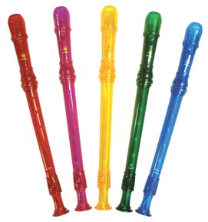
Please fill out the attached form and return it with cash or a check (payable to Bear Canyon Elementary School) to Mr. Miller by Friday, September 30th. If you have any questions, please feel free to contact me via email.

Sincerely,

Andrew Miller
Elementary General Music Teacher
BCE Choir Director
Bear Canyon Elementary School
atmiller@dcsdk12.org
www.musicmiller.weebly.com
Recorder Order Form

Student Name: _________________________________________________

Grade: _________________ Teacher: ______________________________

Please check all that apply

__________ My child already has a recorder to use in class

__________ My child will purchase a recorder (please
enclose $5.00)

Please circle the color of the recorder below:

Red Orange Yellow Green Blue Purple Pink Black

__________ My child will purchase a neck strap (please enclose $1.00). Neckstraps are not mandatory but helpful in holding the recorder.

Please circle the color of the neckstrap below:

Red Orange Yellow Green Blue Purple Pink Black

__________ I would like to donate money to help purchase a recorder for a family in need.

Total Enclosed: ____________________
(Please specify if paid through cash or check # made payable to Bear Canyon Elementary School)

