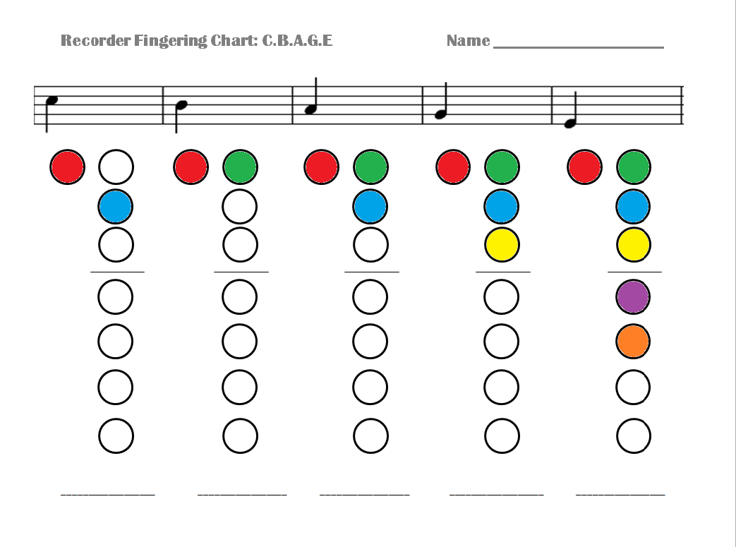
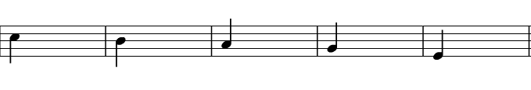

E
A
B
C
__________________ _________________ _________________ __________________ _________________
G
G
EG

