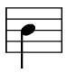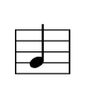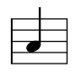**NAME ­­­­­­­­­______________________________________________**

Recorder fingering chart #1

**LEFT**

**LEFT**

**RIGHT**

**RIGHT**

**G**

**A**

**B**